**Product Recommendation System With Sentiment Based Ranking**

**INTRODUCTION**

The recommendation system developed here is used to search for Walmart catalogue and provide an Item based recommendations for the queried item ordered based on sentiments of prior users of the product. As per the given requirements this application consumes the Walmart API services. Users of this system are the Walmart customers for whom this system provides suggestions based on their search criteria.

**Overview Of The System:**

The system queries the Walmart product catalogue by capturing the product name parameter from the user and consuming the search API to retrieve a set of matching items. Following this internally the system selects the first matching product and using its ID queries the Recommendation API. The API retrieves all the recommended products for the given ID. We select the first 10 (if less we take this completely). Now for each of the recommended product we gather its reviews by calling the Review API with product ID as parameter. Once we have the list of user reviews we invoke the IBM alchemy API for text based sentiment analysis on each of its reviews. Each review is classified as positive or negative and a score is computed by the service. The result returned has item’s Id and its score. The positivity (or negativity) level of the item is used to rank the products in descending order. This gives a list of most to least recommended items for the product being searched by the customer.

**Flowchart**:

**SEARCH RESULT SET**

**TRY AGAIN LATER**

**MAX TRY<5:**

**INVALID STRING**

**STRING VALIDITY**

**VALID SEARCH STRING**

**SEARCH API INVOCATION**

**SEARCH STRING**

**CUSTOMER**

**NO SUCH PRODUCT EXISTS**

**PRODUCT**

**PRODUCT EXISTS IN CATALOGUE**

NO RECOMMENDATION

**PRODUCT ID OF FIRST ITEM**

**NONE**

**RECOMMENDATION**

**RECOMMENDATION API INVOCATION**

**RECOMMENDED FIRST 10 PRODUCTS**

**SENTIMENT ANALYZER**

**&**

**SCORE CALCULATOR**

**REVIEW TEXT**

**REVIEWS API INVOCATION**

**REVIEWS**

**NO REVIEW ERROR**

**FOR EACH ID**

**TILL ALL 10 PRODUCT ID’S REVIEWS ARE RETRIEVED**

**RANKED RECOMMENDATION OF SEARCH PARAMETER**

|  |  |
| --- | --- |
|  | **Technology/Tools Used** |
| 1 | Java |
| 2 | Spring |
| 3 | JUnit |
| 4 | log4j |
| 5 | Eclipse IDE |
| 6 | Maven |
| 7 | Postman |

Steps to set up,build and execute the code

1. Code is available on <https://github.com/nitzleo13/walmart-rank>
2. Download code into your machine.
3. Open command prompt and navigate to directory containing pom.xml file
4. Execute mvn clean compile install

If you choose to set up the code in eclipse, execute mvn eclipse:eclipse as well

1. Navigate to directory containing the built binary (jar file). (target directory)
2. Execute

java -jar RankedRecommendation-1.0-SNAPSHOT.jar

1. The jar will execute and prompt for input…you should be able to enter search terms and see results

Example: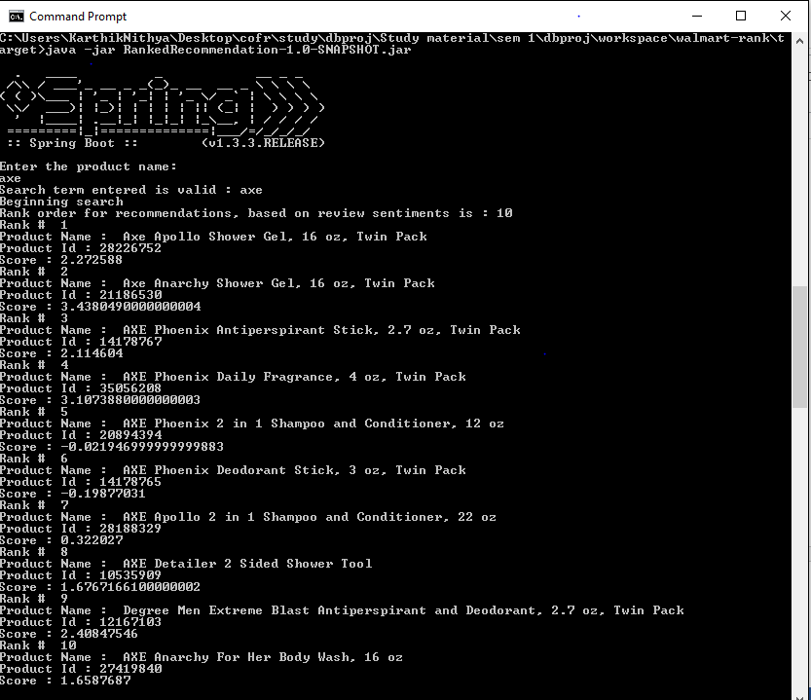

2.

